 

**The Effects of Climatic Trends, Variability, and Rates of Change On Mammalian Brain Evolution**

Brian M. Schildera

*aDepartment of Anthropology, Center for Advanced Study of Hominid Paleobiology,*

*The George Washington University, USA*

*E-mail address*: [schilder@gwmail.gwu.edu](mailto:schilder@gwmail.gwu.edu)

*Mailing address*: 2110 G St, NW, Washington, DC 20052, USA

*Telephone*: 1-202-994-5923 (Lab)

*Keywords*: Variability selection, brain evolution, encephalization, paleoclimate, climate forcing, isotopes

**Abstract**

Explanations for the dramatic brain size increase observed in the hominin lineage have inspired a wide variety of competing explanations for this hallmark evolutionary adaptation. Large-scale climatic hypotheses have traditionally focused on either 1) the effect of consistent trends towards cooler temperatures, aridity, or increasing proportion of C4 vegetation, or 2) increasing variability in these climatic variables. However, this assumes a false dichotomy between these models of climatic selection when it is far more likely that these interrelated types of global climatic change are neither mutually exclusive nor the only factors that drove hominin encephalization. Furthermore, almost all tests of these hypotheses to date have investigated hominin specimens to the exclusion of other mammalian taxon. The present study seeks to quantify the relative contribution of consistent trends, variability, as well as rates of climatic change across a wide variety of hominin and non-hominin mammalian species in order to more comprehensively understand the effects of global climate on brain size as a general principle of mammalian evolution.

**Introduction**

The human lineage underwent rapid increased brain size relative to body size, over the course of the past 2.6Mya, beginning with the advent of *Homo* (Schwartz and Tattersall, 2004; Holloway, 2008; Klein, 2009). Numerous hypotheses have been posited to account for this defining event in hominin evolution ranging from the exploitation of animal/aquatic resources via hunting and/or scavenging (Broadhurst et al., 1998), food cooking (Carmody and Wrangham, 2010), enhanced social complexity (Shultz and Dunbar, 2007; Dunbar, 2009; Shultz and Dunbar, 2010a), and many others. In addition to these small-scale selective forces, large-scale environmental shifts in temperature, aridity, vegetation over the course of hominin evolution have been promoted as the primary driving force underlying hominin encephalization (Vrba, 1996).

Within the climate-oriented hypotheses, there are two main categories. Consistency Selection proposes that trends of long-term change in the climate, drive evolution in a unidirectional manner (Potts, 1998a). Variability Selection, to the contrary, proposes that multigenerational exposure to increased variability of these same climatic factors drove hominins to become unusually encephalized mammals. (Potts, 1996; 1998b; 1998a; 2012). While often advertised as such, these are not necessarily mutually exclusive hypotheses as both can indirectly exert selective pressures on a given taxa at the same time.

Variability Selection outlines three main evolutionary scenarios for taxa when climatic variability increases dramatically (Potts, 2012). The species may either go extinct due to its inability to adapt to the changing environment, it may move and follow the habitat to which it was originally adapted to as that habitat shifts its geographic distribution, or it may adapt to the changing habitat by becoming more versatile. One of the proposed means of achieving versatility is by evolving larger brains to enhance behavioral plasticity in constantly changing environments with different sets of exploitable resources. Both the cognitive buffering hypothesis (Sol, 2009) and the brain size-environmental change hypothesis (Sol, Duncan, Blackburn, Cassey, & Lefebvre, 2005) predict that animals with bigger brains have increased survival rates in novel or changing environments, in part due to enhanced capacity for behavioral innovation (Lefebvre, Reader, & Sol, 2004). In support of this reasoning, it has been demonstrated that mammals (Sol, Bacher, Reader, & Lefebvre, 2008) and birds (Sol et al., 2005) with greater relative brain size have increased survival rates introduced into new environments.

There are many different sources of variability that arise from multiple levels of global climate, including variations in the periodic orbital cycles of the planet (Figure 1). These sources of variation interact at different levels (e.g. global, regional, local) and at different time scales (e.g. 400k, 100k, 40k, seasonal) to create complex downstream effects on local ecology. While we currently lack the means to understand all the intricacies of these interactions it may nevertheless be possible to detect general patterns of evolutionary change induced by global-level fluctuations in climate. In this way, environmental variability is analogous to how brain wave oscillations, which can be recorded by Electroencephalography (EEG), reflect the aggregate firing cycles of millions of interconnected neurons. While EEG cannot directly measure how individual neurons are firing (i.e. the local ecology), it can still identify meaningful patterns of brain activation that correlate with specific cognitive processes (i.e. trends in mammalian evolution).

While there have been previous attempts to investigate the effects of global climate change on hominins brain size, each of these studies have only tested limited subsets of climatic variables, measures of brain size, and time intervals (Ash and Gallup, 2007; Bailey and Geary, 2009; Shultz and Maslin, 2013). Furthermore, none of these studies have included a sample of other mammalian taxa to see if climate can select for larger brains as a general principle of mammalian evolution. The first purpose of the present study is test whether different aspects of global climatic change can drive mammalian brain evolution. The hypotheses tested will include:

a) *Variability Selection*: Increased climatic variability in terms of temperature and vegetation correlates with increased brain size.

b) *Consistency Selection*: Trends towards colder temperatures and increased proportion of C4 vegetation correlate with increased brain size.

c) *Tempo Selection*: A novel hypothesis proposed here that predicts increased rates of temperature and vegetation change will correlate with increased brain size.

The author acknowledges that these hypotheses are by no means mutually exclusive and that it is unlikely any one of these hypotheses will fully account for all variance in mammalian brain size. Rather, this study attempts to reveal the relative contributions of each of these aspects of global climate (if any) to brain size.

The second purpose of this study is to investigate the whether other mammalian taxa respond to climatic change with increases in brain size over evolutionary time. Furthermore, comparing taxa that display responses to climatic change similar to the pattern displayed by hominins may provide insight into the ecological conditions necessary to induce encephalization.

**Methods**

*Biological data*

Non-hominins Biological variables for 508 extant and extinct mammalian taxa from six different Orders (Artiodactyla [*n*=45], Carnivora [*n*=290], Cetacea [*n*=58], the polyphyletic Insectivora [*n*=30], Perissodactyla [*n*=24], and non-hominin Primates [*n*=61]) were extracted from the Shultz & Dunbar supplementary dataset (2010a). Biological variables for each specimen included: Cranial Capacity (CC), Body Size, Encephalization Quotient (EQ) (Martin, 1981). However, a complete interpretation of CC, Body Size, and EQ and their interrelated dynamics is outside the scope of this study. Furthermore, CC appears to best predict intelligence {Deaner:2007jf}and the ability to adapt to novel environments (Sol et al., 2008). Therefore only results regarding CC will be reported hereafter.

Each specimen was assigned an associated date (Mya) corresponding to the emergence of that species. Mya for each extant specimen was estimated from the molecular divergence time, whereas that of the extinct specimen was based on First Appearance Datum (FAD). Any error associated with these measures was equally distributed across all Orders and Suborders (Shultz and Dunbar, 2010a).

Hominins For the hominin sample, CC and Mya for 184 individuals were extracted from a compiled dataset from Shultz, Nelson, & Dunbar (2012). These individuals were fit into a scheme of 11 different hominin species (*Australopithecus afarensis* [*n*=5], *Australopithecus africanus* [*n*=8], *Australopithecus garhi* [*n*=1], *Homo habilis* [*n*=10], *Homo rudolfensis* [*n*=3], *Homo ergaster* [*n*=6], *Homo georgicus* [*n*=3], *Homo erectus* [*n*=33], *Homo heidelbergensis* [*n*=21], *Homo neanderthalensis* [*n*=27], and *Homo sapiens* [*n*=58]).

*Environmental data*

Isotopes High-resolution oxygen-isotope (∂18O) and carbon-isotope (∂13C) records calibrated to the standard geomagnetic polarity time scale (GPTS) were extracted from the literature (Zachos et al., 2001). Zachos et al. (2001) culled this data from deep-sea core isotope records from 40 different sites around the world spanning from present day to 65Mya. Since isotopic values do not vary by site, it is appropriate to use the combined dataset as a proxy for global climate change. While records do not necessarily reflect the specific regional and or local values at those times, they do provide proxy for large-scale climatic shifts that can in turn differentially affect various regions through a network of complex environmental interactions (Figure 1).

Measures of standard deviation (SD), mean, and slope were calculated for both ∂18O and ∂13C records. SD served as a proxy for environmental variability, while mean served as a proxy for directional environmental trends, and slope served as a proxy for the rate of environmental change.

Intervals Six different time intervals were applied to the analysis of each species. These intervals correspond to different periodic orbital cycles of the planet that can force large-scale climate change, including orbital obliquity (at 40k) and orbital eccentricity (at 100k, 200k, & 400k) (Figure 1) (Potts, 1998a; Zachos et al., 2001). 1My and 5My intervals were also investigated in an attempt to capture a large number of climatic events per unit (Foley, 1994). For example, if a species appeared at 2Mya, that species’ biological variables would each be correlated with each climatic measure (i.e. SD, mean, and slope) over the course of 2-2.04Mya (40k interval), then 2-2.1Mya (100k interval), and then repeated for all six intervals for all species.

*Analyses*

Following Ash & Gallup (2007), Spearman’s rank-order correlations were used to account for asymmetrical distributions and the presence of outliers. Correlation coefficients (*r*) were calculated for comparisons between all biological variables (CC, body size, and EQ) and all environmental measures (∂18O SD, mean, and slope, as well as ∂13C SD, mean and slope) in SPSS 21. This procedure was repeated for all six time intervals (40k, 100k, 200k, 400k, 1My, and 5My). A Bonferonni correction was used (α=.05/number of comparisons=.05/98,352=.0000005) to correct for multiple comparisons.

Analyses were first conducted for all non-hominin taxa grouped together, then repeated when divided by six orders and then again by eight suborders. This afforded the ability to look into the results with more detail by determining the differential contributions of individual orders or suborders towards overall mammalian results. The prohibitively small sample size of some suborders (e.g. archaeoceti within the order cetaceans, as well as all of the insectivore suborders) precluded their ability to be included in the suborder-level analyses. Hominins were analyzed separately from non-hominin Primates so as to be able to observe any differences or similarities between these groups.

*Composite scores*

Temporal change To investigate whether brain size has increased as a function of time, correlation coefficients were calculated for ‘CC vs. Mya’ over the course of 65My. To observe the relative contributions to these effects, temporal change was calculated for all non-hominin taxa grouped together, then at the order level, and then again at the suborder level. As mentioned before, values for hominins were calculated separately.

Climatic Response Profile In order to effectively summarize the large number of climatic results in a meaningful way, a composite score called the Climatic Response Profile (CRP) was also developed to observe the responsiveness of CC to each aspect of climatic change (variability, trend, and rate). CRP was derived from the sum of the correlation coefficients (*r*) of ‘Cranial Capacity vs. Temperature’, and ‘Cranial Capacity vs. Vegetation’ for each climatic measure, and then aggregated across all time intervals. CRP was also calculated for all whole sample, order, and suborders levels, with hominins calculated separately.

**Results**

*Temporal change*

Orders When taken as whole, it first appeared as though mammals in general shared a trend towards increasing CC with the progression of time over the past 65My (*n*=508, *r*=.286, df=507, *p*=.000) (Figure 2.A). However, after dividing the sample into orders, it was instead revealed that there were differential degrees of contribution amongst the different taxa. Artiodactyls (*n*=45, *r*=.644, df=44, *p*=.000), Carnivores (*n*=289, *r*=.261, df=288, *p*=.000), and Perissodactyls (*n*=24, *r*=.680, df=23, *p*=.000) showed CC increase over time. By contrast, Cetaceans (*n*=58, *r*=.375, df=57, *p*=.004), Primates (*n*=61, *r*=.335, df=60, *p*=.008), and Insectivores (*n*=30, *r*=.189, df=29, *p*=.318) did not show any significant change in CC over time.

Suborders However, when these taxa were further divided into suborders, a more informative and complex picture emerged (Figure 2.B). Odontocetes of the order Cetacea (*n*=52, *r*=.375, df=51, *p*=.006) remained neutral in terms of CC change over time. However closer inspection revealed that within the order Artiodactlya, Tylopods (*n*=14, *r*=.884, df=13, *p*=.000) but not Ruminants (*n*=24, *r*=.630, df=23, *p*=.001) were contributing to the significant time-dependent CC increase of their order. Similarly, within the order Carnivora, Feliformes (*n*=109, *r*=.472, df=108, *p*=.000) show CC increase but not Caniformes (*n*=181, *r*=.144, df=180, *p*=.053). Within the order Perissodactyla, Ceratomorphs (*n*=12, *r*=.889, df=11, *p*=.000) show CC increase but not Hippomorphs (*n*=12, *r*=.597, df=11, *p*=.041). Within the order Primates, the very significant time-dependent CC increase seen in Haplorrhines (*n*=12, *r*=.889, df=11, *p*=.000) was previously masked by the lack of significant CC temporal change Strepsirrhines (*n*=26, *r*=.007, df=25, *p*=.974) when observed at the order level. Interestingly, amongst all comparisons there were no instances of CC being negatively correlated with time.

Hominins Lastly, it is particularly notable that hominins displayed by far the greatest increase in CC over time when analyzed both by species (*n*=11, *r*=.966, df=10, *p*=.000) and by individuals (*n*=184, *r*=.888, df=183, *p*=.000).

*Climatic Response Profile*

Responsiveness intensity Responsiveness of CC to a given aspect of the CRP for each taxa were operationalized into one of four main categories of intensity: no responsiveness (CRP=0), weak (0<CRP<2), moderate (2≤CRP<4), and strong (4≤CRP).

Orders For CRP score, when all taxa were analyzed together it first appeared as though mammalian CC in general (i.e. ALL ORDERS) was moderately responsive to climatic Trend (*n*=508, CRP=2.839), weakly responsive to Variability (*n*=508, CRP=1.263), and very weakly responsive to Rate (*n*=508, CRP=.181) (Figure 3.A). However, as was seen in measures of temporal change, dividing this sample into respective orders gave a more complete illustration of which orders were contributing towards the general mammalian pattern of results. As with brain size as a function of time, Cetacea (*n*=58, CRP=.000 for all measures), Insectivora (*n*=30, CRP=.000 for all measures), and Primates (*n*=61, CRP=.000 for all measures) showed no significant CC responsiveness to any of climate change. Artiodactyla showed weak responsiveness to Rate (*n*=45, CRP=.538) while Perissodactyla showed weak responsiveness to Trend (*n*=24, CRP=.660). In contrast, Carnivores showed weak responsiveness to Rate (*n*=289, CRP=1.172) and Variability (*n*=289, CRP=1.613), and moderate responsiveness to Trend (*n*=289, CRP=3.946).

Suborders When further divided into the suborders, differential contributions to results at the order level were revealed. Of the order Cetacea, Odontoceti remain unresponsive (*n*=52, CRP=.000). When order Artiodactyla was divided into suborders, neither Ruminants (*n*=24, CRP=.000) nor Tylopods (*n*=14, CRP=.000) showed significant responsiveness to any aspects of CRP. Caniformes displayed weak responsiveness to Variability (*n*=181, CRP=1.760), Trend (*n*=181, CRP=1.140), and Rate (*n*=181, CRP=.318) whereas Feliformes showed greater overall effects with weak responsiveness to Variability (*n*=109, CRP=.733) and Rate (*n*=109, CRP=2.002) but strong responsiveness to Trend (*n*=109, CRP=3.958). Within the order Perissodactyla, Hippomorphs appeared to drive the order level effects given their weak responsiveness to Variability (*n*=12, CRP=.000) and Trend (*n*=12, CRP=.000). Whereas Ceratomorpha were completely unresponsive across all climatic measures (*n*=12, CRP=.000). Within Primates, it was revealed that in fact Haplorrhines were moderately responsive to Rate (*n*=206, CRP=3.028), and strongly responsive to Variability (*n*=206, CRP=4.498) and Trend (*n*=206, CRP=6.183) to a degrees that were greater than any of the other non-hominin taxa. This was not apparent at the order level because, much like with the temporal change measure, Strepsirrhines were masking these results with their complete lack unresponsiveness across all climatic measures (*n*=26, CRP=.000)

Hominins Relative to all other non-hominin taxa, hominins displayed the strongest responsiveness to Trend (*n*=184, CRP=6.318) with moderate responsiveness to Rate (*n*=184, CRP=1.923) and extremely weak responsiveness Variability (*n*=184, CRP=.022) (Figure 4.A). To investigate the sources these effects more closely, the hominin CRP score was broken into the temperature (∂18O) and vegetation (∂13C) components (Figure 4.B). This unveiled that the strong responsiveness to overall CRP Trend was primarily driven by a Trend towards cooler temperatures (higher mean ∂18O values) (*n*=184, CRP=5.391) with only weak contributions from temperature Variability (*n*=184, CRP=.9660), and Rate (*n*=184, CRP=.959), as well as vegetation Variability (*n*=184, CRP=-.944), Trend (*n*=184, CRP=.927), and Rate (*n*=184, CRP=.964).

An additional analysis was conducted to investigate the comparability of hominins and Carnivores CRP scores over the course of the past 3.2My (the earliest hominins specimen date). Carnivores were chosen as a comparison taxa for two reasons: 1) the order Carnivora was the only other taxonomic group with a sample size large enough from 3.2Mya-present to conduct this analysis (*n*=22), and 2) to test whether similarities between the CRP of hominins and Carnivora might reflect their shared occupation of the predator ecological niche. Results revealed that Carnivora were actually quite unlike hominins in that they displayed only weak and inverse responsiveness to overall CRP Variability (*n*=22, CRP=-1.388) but not to Trend or Rate (*n*=22, CRP=.000) (Figure 4.C). An almost identical pattern emerged the CRP score was broken down into temperature Variability (*n*=22, CRP=.964) and vegetation Variability (*n*=22, CRP=.964) (Figure 4.D) but not temperature or vegetation Trend or Rate (*n*=22, CRP=.000). For all Variability measures, Carnivores actually displayed a negative correlation between CC and the magnitude of Variability, and were largely dissimilar to hominins.

**Discussion**

*Temporal change*

As a preliminary means of assessing whether brain size generally increased over time in certain taxa, CC was correlated with the respective age of each species. The results of this analysis showed that Artiodactyls, Carnivores, Perissodactyls, and Hominins have all evolved larger brains within the last 65Mya, confirming results from the original publication of the biological dataset (Shultz and Dunbar, 2010b). This is not to say that every taxa was increasing their brain size at every point in time. Indeed, different orders/suborders have only first emerged at different points within that 65My timeframe.

*Climatic Response Profile*

While temporal analyses can inform researchers as to whether or not brain size increase occurred over time, the goal of the climatic analyses is to assess which global-scale environmental factors, if any, may have indirectly driven these brain size increases. In general, this study found that Variability, Trend, and Rate can all effect CC increase. However, none of these factors in isolation account for all instances of CC increase across all taxa. Even within taxa at the levels of order and suborder, combinations of Variability, Trend and Rate in different proportions can all contribute towards driving brain size increase. All three of these climatic factors appear to play a significant role in Caniforme, Feliforme, and Haplorrhine brain increase.

This perspective contrasts with highly polarized views of which climatic variables are most tightly tied to brain evolution. Particularly when it comes to the event of hominin brain expansion, researchers have often relied upon models based on either Variability Selection (Potts, 1996; 1998b; 2012) or Consistency Selection (Vrba, 1996), favoring one hypothesis over another. Given that mammalian, including hominin, brain evolution was unlikely to have been driven by any single factor, it is much more parsimonious to assume that some combination of Variability, Trend and other factors including Rate influenced brain evolution. Furthermore, these various climatic factors are highly interrelated, and can interact with one another in complex ways to produce additional layers of patterns of climatic change.

With that in mind, amongst the climatic measures, Trend accounts for the greatest proportion of CC increase in Feliformes, Haplorrhine, and hominins, suggesting that these taxa are responding similarly towards global shifts in cooling and increased proportion of C4/CAM vegetation. However, more detailed comparisons between Carnivores and hominins (Figure 4.A-D) showed that these similarities did not remain when only focusing on the last 3.2My. This suggests that as a general rule, Carnivore CC has been responsive to a trend in global cooling in the past, but not at the same time that hominin CC was responding to the same climatic factor. This precludes using Carnivores as a comparative model for hominin brain evolution over the last 3.2Mya as the contexts in which these two taxa became encephalized were quite different in time and space.

The fact that different mammalian taxa respond differently to the same global climatic conditions suggests that 1) other large-scale factors (e.g. changes in regional aridity) and small-scale factors (e.g. Local ecology, social group structure) affect brain size increase, and 2) how climatic change affects mammalian brain evolution depends on the evolutionary and ecological context of a given taxa.

**Conclusions**

From this study, two main conclusions can be drawn. The first is that climatic Variability, Trend, and Rate (in terms of both temperature and vegetation) have all served as indirect drivers of mammalian brain expansion, albeit not for every mammalian taxa at every point in time. The second is that much like Carnivores and Haplorrhines, hominins displayed the strongest CC increase responsiveness to trends in global cooling. Taken together, it appears that hominin brain size was primarily responding to global cooling. However, as mentioned earlier, the drivers behind hominin encephalization were multifactorial and cannot be attributed to a single measure of climatic change.

**Acknowledgements**

The author would like to thanks Brian Richmond, Bernard Wood, Rene Bobe, Chet Sherwood, and John Kingston for their invaluable feedback and direction throughout this project.

**References**

Ash, J., Gallup, G.G., Jr., 2007. Paleoclimatic Variation and Brain Expansion during Human Evolution. Human Nature. 18, 109–124.

Bailey, D.H., Geary, D.C., 2009. Hominid Brain Evolution. Human Nature. 20, 67–79.

Broadhurst, C.L., Cunnane, S.C., Crawford, M.A., 1998. Rift Valley lake fish and shellfish provided brain-specific nutrition for early Homo. The British journal of nutrition. 79, 3–21.

Carmody, R.N., Wrangham, R.W., 2010. Cooking and the Human Commitment to a High-quality Diet. Cold Spring Harbor Symposia on Quantitative Biology. 74, 427–434.

Deaner, R.O., Isler, K., Burkart, J., van Schaik, C., 2007. Overall Brain Size, and Not Encephalization Quotient, Best Predicts Cognitive Ability across Non-Human Primates. Brain, Behavior and Evolution. 70, 115–124.

Dunbar, R.I.M., 2009. The social brain hypothesis and its implications for social evolution.

Foley, R.A., 1994. Speciation, extinction and climatic change in hominid evolution. Journal of Human Evolution. 26, 275–289.

Holloway, R.L., 2008. The Human Brain Evolving: A Personal Retrospective. Annual Review of Anthropology. 37, 1–19.

Klein, R.G., 2009. The Human Career. University of Chicago Press.

Martin, R.D., 1981. Relative brain size and basal metabolic rate in terrestrial vertebrates. Nature. 293, 57–60.

Potts, R., 1996. Evolution and climate variability. Science. 273, 922–923.

Potts, R., 1998a. Variability selection in hominid evolution. Evolutionary Anthropology: Issues, News, and Reviews. 7, 81–96.

Potts, R., 1998b. Environmental hypotheses of hominin evolution. American journal of physical anthropology. Suppl 27, 93–136.

Potts, R., 2012. Environmental and Behavioral Evidence Pertaining to the Evolution of Early Homo. Current Anthropology. 53, S299–S317.

Schwartz, J.H., Tattersall, I., 2004. The Human Fossil Record, Brain Endocasts--The Paleoneurological Evidence. John Wiley & Sons.

Shultz, S., Dunbar, R., 2010a. Encephalization is not a universal macroevolutionary phenomenon in mammals but is associated with sociality. PNAS. 107, 21582–21586.

Shultz, S., Dunbar, R., 2010b. Encephalization is not a universal macroevolutionary phenomenon in mammals but is associated with sociality. PNAS. 107, 21582–21586.

Shultz, S., Dunbar, R.I.M., 2007. The evolution of the social brain: anthropoid primates contrast with other vertebrates. Proceedings of the Royal Society B: Biological Sciences. 274, 2429–2436.

Shultz, S., Maslin, M., 2013. Early Human Speciation, Brain Expansion and Dispersal Influenced by African Climate Pulses. PloS one. 8, e76750.

Shultz, S., Nelson, E., Dunbar, R.I.M., 2012. Hominin cognitive evolution: identifying patterns and processes in the fossil and archaeological record. Philosophical Transactions of the Royal Society B: Biological Sciences. 367, 2130–2140.

Sol, D., Bacher, S., Reader, S.M., Lefebvre, L., 2008. Brain size predicts the success of mammal species introduced into novel environments. The American naturalist. 172 Suppl 1, S63–71.

Vrba, E.S., 1996. Climate, heterochrony, and human evolution. Journal of Anthropological Research. 52, 1–28.

Zachos, J., Pagani, M., Sloan, L., Thomas, E., Billups, K., 2001. Trends, rhythms, and aberrations in global climate 65 Ma to present. Science. 292, 686–693.

**Figures**



Figure 1. A diagram displaying the interactive relationships between sources of

environmental variability.

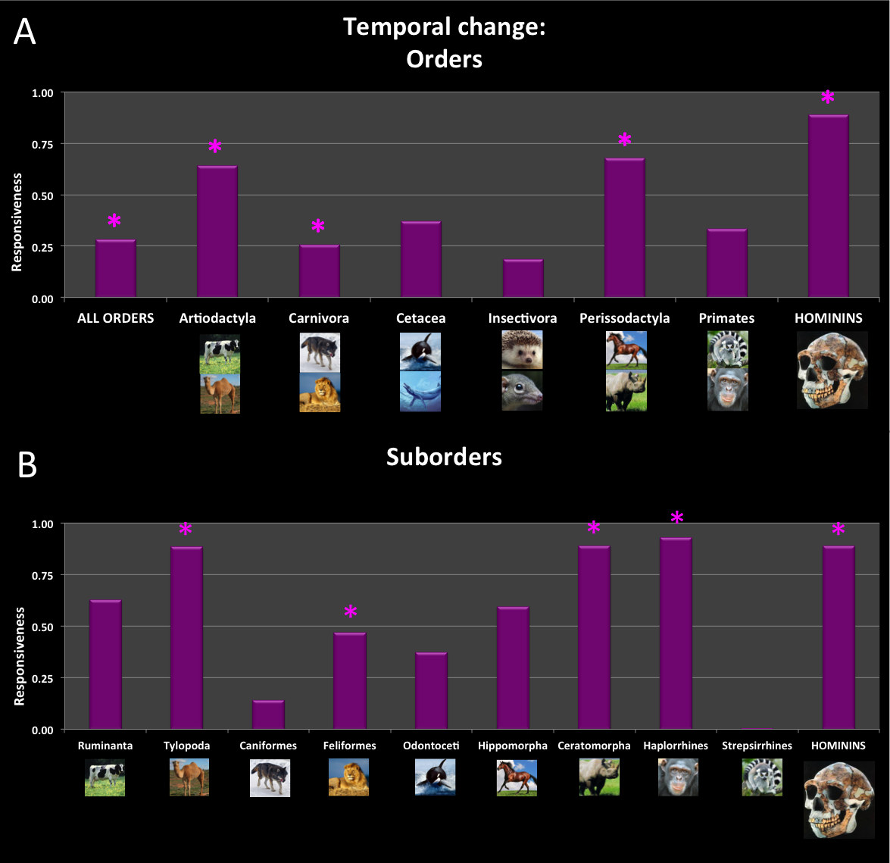

Figure 2. Temporal change for all taxa over the past 65My divided by (A) order, and (B) suborder. The y-axis refers to the responsiveness of cranial capacity to the progression of time. Asterisks (*) indicate statistical significance (p≤.000).

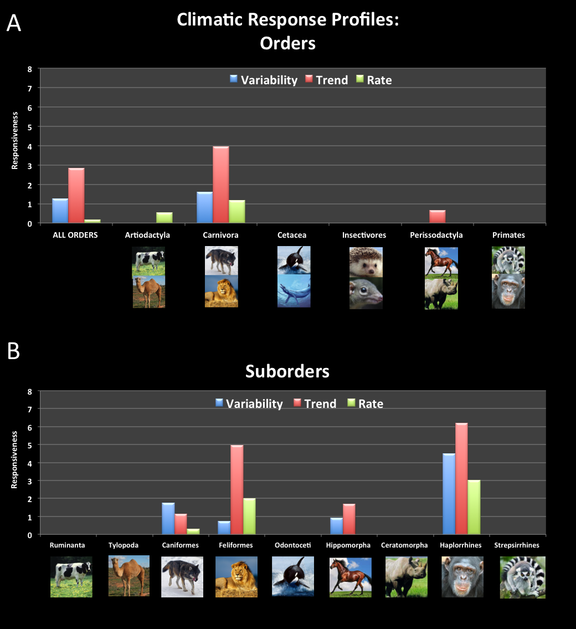

Figure 3. Climatic Response Profiles for all taxa over the past 65My divided by (A) order, and (B) suborder. The y-axis refers to the responsiveness of cranial capacity to the progression of time. Asterisks (*) indicate statistical significance (p≤.000).

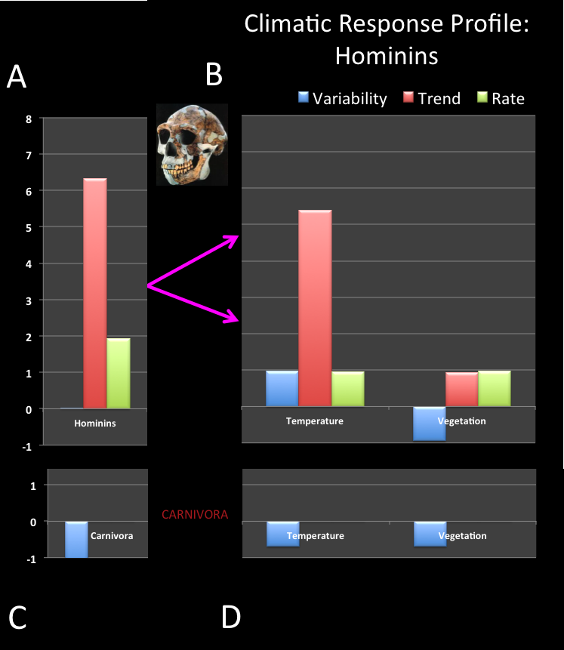

Figure 4. Climatic Response Profiles for (A) hominins. (B) Hominin data

was then divided by temperature and vegetation measures. (C) For

comparison, Carnivores over the past 3.2My are plotted by CRP score,

which was then divided into temperature and vegetation measures (D).

The y-axis refers to the responsiveness of cranial capacity to either climatic

variability, trend or rate. Asterisks (*) indicates statistical significance

(p≤.000).

**SUPPLEMENTARY MATERIALS**







